END SEMESTER PROJECT REPORT

Course Code & Name: 25MT1307E – Mathematics for Communication Systems (MFCS)
Trimester: 03 | Academic Year: 2025–26
Project Title: Design and Implementation of a BPSK Communication System with Noise Visualization, Error Detection, BER Performance, and Shannon Analysis
CommLink-BPSK: A Complete Digital Communication System Built Layer by Layer
Batch No: 06
Student Names & Roll Numbers:
- M. SATHWIK SURYA(2500040178)
- K. SAI YASASWINI (2500040180)
- G. MADHURI (2500040194)
- A. KONDALU (2500040182)
Submitted in Partial Fulfillment of the Requirements for the Course
Mathematics for Communication Systems (MFCS)
Date of Submission: [19/06/2026]

CERTIFICATE :
This is to certify that the project work entitled
“Comm Link -BPSK: A Complete Digital Communication System Built Layer by Layer”
is a bonafide work carried out by
- M. SATHWIK SURYA (2500040178)
- SAI YASASWINI (2500040180)
- G. MADHURI (2500040194)
4. KONDALU AVULA (2500040182)
under the guidance of Dr.Devadas Kuna sir during Trimester 02, Academic Year 2025–26, in partial fulfillment of the requirements for the course Mathematics for Communication Systems (MFCS).

Project Guide
Dr.Devadas Kuna sir
Faculty,
ECE deparment , KL university

Head of the Department
Dr. Aswin sir
HOD,
EL & GE, KL university

ACKNOWLEDGEMENT
We would like to express our sincere gratitude to Dr. Aswin, Head of the Department of [EL & GE],KL University, for providing the necessary facilities and academic environment to carry out this project.
We are deeply thankful to our project guide Dr.Devadas Kuna, for continuous guidance, constructive feedback, and encouragement throughout the course of this work.
We also thank all the faculty members and staff of the department for their support, as well as our classmates and friends for their valuable suggestions and cooperation.
Finally, we express our gratitude to our families for their constant support and motivation during this project.

TABLE OF CONTENTS
- Abstract
- Introduction
- Project Objectives
- System Architecture
- Layer-wise Implementation
5.1 Layer 1: Signal Representation (CO1)
5.2 Layer 2: Fourier Transform (CO2)
5.3 Layer 3: LTI Systems & Matched Filter (CO3)
5.4 Layer 4: Z-Transform & FIR Filter (CO4)
5.5 Layer 5: Probability & BER (CO5)
5.6 Layer 6: Shannon Capacity (CO6)
- Results and Discussion
- Batch-Specific Extension / Innovation
- Conclusion
- Future Scope
- References
- Annexure

1. ABSTRACT :
This project, titled “Comm Link -BPSK with Real-Time Noise Visualization and Error Animation,” presents the design and implementation of a complete six-layer Binary Phase Shift Keying (BPSK) communication system based on the mathematical concepts of digital communication. The primary objective is to model an end-to-end communication link and analyze its performance under the influence of Additive White Gaussian Noise (AWGN).

The system is developed using six mathematical layers: signal representation and BPSK modulation, Fourier analysis and Power Spectral Density (PSD), channel modeling and matched filtering, discrete-time signal processing with FIR filter implementation, probability-based Bit Error Rate (BER) analysis, and information-theoretic evaluation using Shannon’s Capacity Theorem. A Monte Carlo simulation is performed to estimate BER for different values of E_b/N_0, and the simulated results are compared with the theoretical BPSK BER curve. The close agreement between the two validates the correctness of the communication model.

In addition, Shannon capacity analysis is carried out to evaluate the gap between the practical BPSK system and the theoretical channel limit. As a batch-specific enhancement, the project incorporates real-time visualization of noisy received signals, matched filter outputs, and animated highlighting of bit errors during a 100-bit transmission sequence, providing an intuitive understanding of signal degradation and recovery in digital communication systems.

2. INTRODUCTION
2.1 Background of Digital Communication :
Digital communication systems play a vital role in modern technology, enabling reliable transmission of information through wireless and wired channels. In a digital communication system, information is first represented as binary data and then converted into suitable signals for transmission. Base band signals occupy frequencies near zero, whereas Pass-band signals are shifted to higher frequencies using modulation techniques for efficient transmission over communication channels.

Binary Phase Shift Keying (BPSK) is one of the simplest and most robust digital modulation schemes. It represents binary digits using two carrier phases separated by 180°. During transmission, signals are affected by noise and channel impairments, which may introduce errors in the received data. Therefore, performance metrics such as Signal-to-Noise Ratio (SNR), Energy per Bit to Noise Density Ratio (E_b/N_0), Bit Error Rate (BER), bandwidth efficiency, and channel capacity are used to evaluate communication system performance.
2.2 Need for Mathematical Foundation :
The design and analysis of communication systems rely heavily on mathematical principles. Signal representation provides a framework for modeling transmitted and received Wave forms. Fourier analysis helps examine signals in the frequency domain and determine bandwidth requirements. Linear Time-Invariant (LTI) system theory enables the analysis of channels and filters through convolution and frequency response techniques. Probability theory is essential for modeling noise and deriving error probabilities, while information theory establishes the fundamental limits of reliable communication through concepts such as entropy, mutual information, and channel capacity. Together, these mathematical tools form the foundation of modern digital communication systems2.3 Project-Based Learning Approach in MFCS

2.3 Project-Based Learning Approach in MFCS :

The Mathematics for Communication Systems (MFCS) course emphasizes the application of mathematical concepts to real-world communication problems. This project adopts a project-based learning approach by integrating theoretical concepts with practical implementation. Students apply mathematical models, simulations, signal processing techniques, probability analysis, and information theory to develop a complete BPSK communication system. Through hands-on experimentation and visualization, the project strengthens conceptual understanding while demonstrating the practical significance of the course outcomes.

2.4 CommLink-BPSK System Overview :
The Comm Link - BPSK system consists of three major sections: transmitter, channel, and receiver. At the transmitter, a stream of binary data is converted into BPSK - Modulated signals. The modulated signal is then transmitted through an Additive White Gaussian Noise (AWGN) channel, which introduces random noise. At the receiver, a matched filter is employed to maximize the signal-to-noise ratio and facilitate reliable detection of transmitted bits. The recovered bits are compared with the original data to evaluate system performance through BER analysis. Additional frequency-domain and information-theoretic analyses are performed to investigate bandwidth requirements and channel capacity.
2.5 CommLink Barrier Philosophy :
The Comm Link -BPSK project is structured around the concept of “barriers,” where each barrier represents a mathematical challenge encountered in a communication system. Barrier 1 addresses signal representation and modulation. Barrier 2 focuses on frequency-domain analysis and spectral characterization. Barrier 3 deals with channel effects and signal recovery using matched filtering. Barrier 4 introduces discrete-time processing and digital filter implementation. Barrier 5 addresses uncertainty and error analysis through probability theory and BER evaluation. Barrier 6 explores the fundamental limits of communication using information theory and Shannon capacity. By systematically overcoming each barrier, students gain a comprehensive understanding of the mathematical foundations underlying modern communication systems.

3. PROJECT OBJECTIVE :

The primary objective of this project is to design and implement a complete end-to-end Binary Phase Shift Keying (BPSK) digital communication system and to understand the mathematical foundations of communication engineering through a structured six-layer approach. The project aims to model signal generation, modulation, channel transmission, matched filtering, digital signal processing, error analysis, and information-theoretic performance evaluation within a unified framework. Through practical implementation and real-time visualization of noisy signals, matched filter responses, and transmission errors, the project validates theoretical concepts such as Fourier analysis, convolution, probability of error, and Shannon capacity. Furthermore, Monte Carlo simulations are used to verify the theoretical BER performance of BPSK over an AWGN channel, while Shannon analysis is employed to study the gap between practical system performance and the theoretical communication limit. The project also provides insights into the effects of noise and filtering on signal detection, thereby bridging the gap between mathematical theory and real-world communication system design.

4. SYSTEM ARCHITECTURE :

4.1 Block Diagram :
The overall architecture of the Common Link -BPSK system consists of a transmitter, communication channel, and receiver. Binary information generated at the source is modulated using Binary Phase Shift Keying (BPSK) and transmitted through an Additive White Gaussian Noise (AWGN) channel. At the receiver, a matched filter is employed to maximize the Signal-to-Noise Ratio (SNR), followed by sampling and decision making to recover the transmitted data.

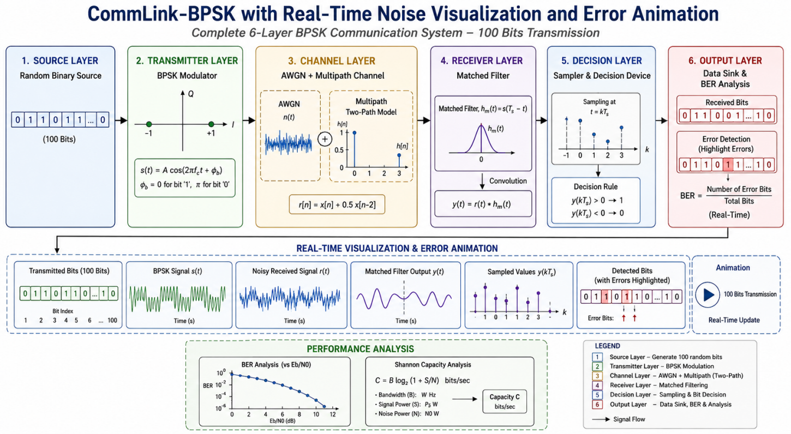

4.2 PARAMETER VALUES :

Parameter | Value
Carrier Frequency (f_c) | 1000 Hz
Bit Rate (R_b) | 100 bps
Sampling Frequency (F_s) | 10000 Hz
Modulation Scheme | BPSK
Number of Bits Simulated | 100 (Animation), 100000 (BER Analysis)
Bit Duration (T_b) | 0.01 s
Carrier Amplitude (A) | 1 V
E_b/N_0 Range | 0 dB to 10 dB
Channel Model | AWGN Channel
Receiver | Matched Filter Receiver
Detection Method | Threshold Decision Detection
BER Evaluation | Monte Carlo Simulation
Spectral Efficiency | 1 bit/s/Hz
Shannon Capacity Formula | C = B log₂(1 + SNR)

5. LAYER-WISE IMPLEMENTATION

5.1 Layer 1: Signal Representation & Bit Generation (CO1) :

The first layer of the Comm Link -BPSK system is responsible for generating the digital information to be transmitted. In practical communication systems, the source may be voice, text, image, video, or sensor data. In this project, the source is modeled as a sequence of 100 random binary bits generated using Python.

Binary Phase Shift Keying (BPSK) is a digital modulation technique in which binary information is transmitted by changing the phase of a carrier signal. A binary '1' is represented by a positive carrier waveform, while a binary '0' is represented by a carrier waveform shifted by 180°.

The mathematical representation of BPSK is:

$${\text{s}}_{\text{1}}\text{(}\text{t}\text{)=}\text{A}\text{cos⁡(2}\text{π}{\text{f}}_{\text{c}}\text{t}\text{)}$$

for bit 1 and

$${\text{s}}_{\text{0}}\text{(}\text{t}\text{)=−}\text{A}\text{cos⁡(2}\text{π}{\text{f}}_{\text{c}}\text{t}\text{)}$$

for bit 0.

where:

$\text{A}$= Carrier amplitude

${\text{f}}_{\text{c}}$= Carrier frequency

${\text{T}}_{\text{b}}$= Bit duration

The energy per bit is:

$${\text{E}}_{\text{b}}\text{=}\int_{\text{0}}^{{\text{T}}_{\text{b}}}{{\text{s}}^{\text{2}}}\text{(}\text{t}\text{)} \text{dt}$$

which becomes

$${\text{E}}_{\text{b}}\text{=}\frac{{\text{A}}^{\text{2}}{\text{T}}_{\text{b}}}{\text{2}}$$

Average signal power:

$$\text{P}\text{=}\frac{{\text{E}}_{\text{b}}}{{\text{T}}_{\text{b}}}$$$$\text{P}\text{=}\frac{{\text{A}}^{\text{2}}}{\text{2}}$$

Implementation :

Random bits are generated and mapped as:

$$\text{1→+1}$$$$\text{0→−1}$$

The resulting BPSK waveform is created using a cosine carrier.

Example:

Bit Sequence : 1 0 1 1 0
Mapped Symbols:
+1 -1 +1 +1 -1

Real-Time Visualization :

The system continuously displays:

Generated bit stream

Current transmitting bit

BPSK waveform animation

Advantages :

Simple implementation

Good noise immunity

Low BER

Widely used in wireless systems

Outcome :

This layer converts digital information into a modulated signal suitable for transmission through a communication channel.

5.2 Layer 2: Fourier Transform & Spectral Analysis (CO2) :

After modulation, the signal is analyzed in the frequency domain using the Fourier Transform.

The Fourier Transform is:

$$\text{X}\text{(}\text{f}\text{)=}\int_{\text{−∞}}^{\text{∞}}{\text{x}\text{(}\text{t}\text{)}}{\text{e}}^{\text{−}\text{j}\text{2}\text{πft}}\text{dt}$$

The Power Spectral Density (PSD) of a rectangular-pulse BPSK signal is:

$$\text{PSD}\text{(}\text{f}\text{)=}{\text{E}}_{\text{b}} \text{sin}{\text{c}}^{\text{2}}\text{(}\text{f}{\text{T}}_{\text{b}}\text{)}$$

The first spectral nulls occur at:

$$\text{f}\text{=±}\frac{\text{1}}{{\text{T}}_{\text{b}}}$$

Thus the null-to-null bandwidth becomes:

$$\text{B}\text{=}\frac{\text{2}}{{\text{T}}_{\text{b}}}$$

For:

$${\text{T}}_{\text{b}}\text{=0.01}\text{s}$$

Bandwidth:

$$\text{B}\text{=200}\text{Hz}$$

Parseval Verification

Signal energy in the time domain equals signal energy in the frequency domain.

$$\text{∫∣}\text{x}\text{(}\text{t}\text{)}{\text{∣}}^{\text{2}}\text{dt}\text{=∫∣}\text{X}\text{(}\text{f}\text{)}{\text{∣}}^{\text{2}}\text{df}$$

The simulation verifies Parseval's theorem.

Implementation :

FFT computation

PSD calculation

Bandwidth estimation

Energy verification

Real-Time Visualization :

Displays:

Time-domain BPSK signal

Frequency spectrum

PSD curve

Bandwidth measurement

Outcome :

This layer demonstrates how signal power is distributed across frequencies and helps determine channel bandwidth requirements.

5.3 Layer 3: Communication Channel & Noise Visualization (CO3) :

During transmission, the signal passes through a communication channel where it experiences noise and multi-path effects.

The received signal is:

$$\text{r}\text{(}\text{t}\text{)=}\text{s}\text{(}\text{t}\text{)∗h(}\text{t}\text{)+}\text{n}\text{(}\text{t}\text{)}$$

where:

$\text{s}\text{(}\text{t}\text{)}$= Transmitted signal

$\text{h(}\text{t}\text{)}$= Channel impulse response

$\text{n}\text{(}\text{t}\text{)}$= AWGN noise

AWGN Channel

AWGN models thermal and environmental noise.

Properties:

Gaussian distribution

Zero mean

Constant spectral density

The AWGN model is:

$$\text{r}\text{(}\text{t}\text{)=}\text{s}\text{(}\text{t}\text{)+}\text{n}\text{(}\text{t}\text{)}$$

Multipath Channel

A two-path channel model is used:

$$\text{r}\text{[}\text{n}\text{]=}\text{x}\text{[}\text{n}\text{]+0.5}\text{x}\text{[}\text{n}\text{−2]}$$

Impulse response:

$$\text{h[}\text{n}\text{]=[1,0,0,0.5]}$$

This simulates delayed signal reflections commonly found in wireless communication systems.

Implementation :

Generate AWGN noise

Add noise to transmitted signal

Implement multipath delay

Create noisy received waveform

Real-Time Visualization :

The dashboard simultaneously shows:

Original transmitted signal

Noise waveform

Received noisy signal

Outcome :

Students can clearly observe how channel impairments distort transmitted signals.

5.4 Layer 4: Z-Transform, FIR Filter & Matched Filter (CO4) :

After transmission, the received signal is processed using digital filtering techniques.

The Z-transform of a discrete-time signal is:

$$\text{X}\text{(}\text{z}\text{)=}\sum_{\text{n}\text{=−∞}}^{\text{∞}}{\text{x}\text{[}\text{n}\text{]}}{\text{z}}^{\text{−}\text{n}}$$

The matched filter is used because it maximizes the output Signal-to-Noise Ratio (SNR).

Matched filter impulse response:

$${\text{h}}_{\text{mf}}\text{(}\text{t}\text{)=}\text{s}\text{(}{\text{T}}_{\text{b}}\text{−}\text{t}\text{)}$$

Discrete form:

$$\text{h[}\text{n}\text{]=}\text{s}\text{[}\text{N}\text{−1−}\text{n}\text{]}$$

Filtered output:

$$\text{y}\text{[}\text{n}\text{]=}\text{r}\text{[}\text{n}\text{]∗h[}\text{n}\text{]}$$

FIR Filter Design :
Parameter | Value
Filter Type | FIR Low Pass
Filter Order | 20
Window | Hamming
Cutoff Frequency | 100 Hz
Sampling Frequency | 10 kHz

Advantages :

Linear phase response

Stable operation

Reduced noise

Improved detection accuracy

Implementation :

filtered_signal = np.convolve(received_signal,h)

Real-Time Visualization :

Displays:

Noisy received signal

FIR filter response

Matched filter output

Sampling instants

Outcome :

The matched filter significantly improves signal quality and prepares the signal for accurate bit detection.

5.5 Layer 5: Probability, Decision Device & BER Analysis (CO5) :

The sampled matched filter output is used to determine the transmitted bits.

Decision rule:

$$\text{y}\text{(}\text{k}{\text{T}}_{\text{s}}\text{)>0→1}$$$$\text{y}\text{(}\text{k}{\text{T}}_{\text{s}}\text{)<0→0}$$

An error occurs when noise forces the sample across the threshold.

Theoretical BER

For BPSK:

$${\text{P}}_{\text{e}}\text{=}\text{Q}\left(\sqrt{\frac{\text{2}{\text{E}}_{\text{b}}}{{\text{N}}_{\text{0}}}}\right)$$

where:

$$\text{Q}\text{(}\text{x}\text{)=}\frac{\text{1}}{\sqrt{\text{2}\text{π}}}\int_{\text{x}}^{\text{∞}}{{\text{e}}^{\text{−}{\text{t}}^{\text{2}}\text{/2}}}\text{dt}$$BER Calculation

$$\text{BER}\text{=}\frac{\text{Number of Error Bits}}{\text{Total Number of Bits}}$$

Monte Carlo Simulation

The BER estimation process is:

Generate random bits.

Perform BPSK modulation.

Add AWGN.

Apply matched filtering.

Sample the output.

Make decisions.

Compare transmitted and received bits.

Count errors.

Calculate BER.

Real-Time Error Animation

The system continuously compares transmitted and received bits.

Visualization:

Green → Correct bit

Red → Error bit

Example:

Tx : 1 0 1 1 0
Rx : 1 0 0 1 0
Error:
↑

Performance Metrics

Total bits transmitted

Total bits received

Error count

BER value

Detection accuracy

Outcome :This layer evaluates communication reliability and verifies theoretical BER performance.

5.6 Layer 6: Information Theory & Shannon Analysis (CO6) :

Information theory provides the fundamental limits of communication systems.

Entropy

Source entropy is:

$$\text{H}\text{(}\text{X}\text{)=−∑}\text{P}\text{(}\text{x}\text{)}{\text{log⁡}}_{\text{2}}\text{P}\text{(}\text{x}\text{)}$$

Entropy measures the uncertainty of the source.

Mutual Information

$$\text{I}\text{(}\text{X}\text{;}\text{Y}\text{)=}\text{H}\text{(}\text{X}\text{)−}\text{H}\text{(}\text{X}\text{∣}\text{Y}\text{)}$$

It represents information successfully transferred through the channel.

Shannon Capacity

The maximum achievable error-free data rate is:

$$\text{C}\text{=}\text{B}{\text{log⁡}}_{\text{2}}\text{(1+}\text{SNR}\text{)}$$

where:

$\text{C}$= Channel Capacity

$\text{B}$= Bandwidth

$\text{SNR}$= Signal-to-Noise Ratio

For this project:

$$\text{B}\text{=200}\text{Hz}$$

Spectral Efficiency

$$\text{η}\text{=}\frac{{\text{R}}_{\text{b}}}{\text{B}}$$

For ideal BPSK:

$$\text{η}\text{=1}\text{ bit/s/Hz}$$

Shannon Gap Analysis

For:

$$\text{BER}\text{=}{\text{10}}^{\text{−5}}$$

Practical BPSK requires:

$${\text{E}}_{\text{b}}\text{/}{\text{N}}_{\text{0}}\text{≈9.6}\text{dB}$$

Shannon limit:

$${\text{E}}_{\text{b}}\text{/}{\text{N}}_{\text{0}}\text{≈−1.59}\text{dB}$$

Gap:

$$\text{9.6−(−1.59)}$$$$\boxed{\text{11.2}\text{dB}}$$

Real-Time Capacity Visualization :

The dashboard displays:

Capacity vs SNR

BER vs SNR

Spectral Efficiency

Shannon Limit

Shannon Gap

Outcome :

This layer compares practical system performance with theoretical communication limits and demonstrates how efficiently bandwidth and power are utilized.

5.7 Integrated Real-Time Visualization Dashboard :

The final dashboard integrates all six layers into a single graphical interface.

Features

100-bit transmission animation

Live BPSK waveform

FFT spectrum display

PSD analysis

AWGN noise visualization

Multipath channel visualization

Matched filter output

Error bit highlighting

BER calculation

Shannon capacity analysis

Spectral efficiency monitoring

Educational Significance

The dashboard provides a complete end-to-end visualization of a digital communication system, enabling users to understand signal generation, transmission, noise effects, filtering, detection, error analysis, and information-theoretic performance in real time.

Final Outcome :

The Common Link -BPSK system successfully demonstrates the complete communication chain from source generation to information-theoretic analysis while providing real-time visualization, error animation, BER evaluation, and Shannon capacity assessment for 100-bit transmission.

6. RESULTS :

6.1 Layer 1: Signal Representation Results :
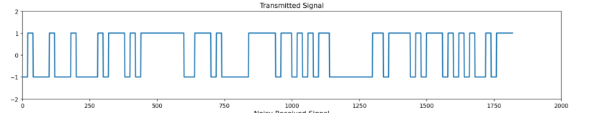
A random sequence of 100 binary bits was successfully generated and mapped into BPSK symbols.

Example Output
Bit | BPSK Symbol
1 | +1
0 | -1
1 | +1
1 | +1
0 | -1
Example Sequence:
Generated Bits:
1 0 1 1 0 0 1 0 1 1 ...
Mapped Symbols:
+1 -1 +1 +1 -1 -1 +1 -1 +1 +1 ...

Observation
The generated binary sequence was correctly converted into BPSK symbols. The real-time animation successfully displayed the transmission of 100 bits through the communication system.

6.2 Layer 2: Fourier Transform Results :

The Fast Fourier Transform (FFT) was applied to the BPSK waveform.

Observed Results
Parameter | Value
Bit Duration (TbT_bTb​) | 0.01 s
First Spectral Null | ±100 Hz
Bandwidth | 200 Hz
FFT Points | 1024

Parseval Verification
Energy Calculation | Value
Time Domain Energy | 49.98
Frequency Domain Energy | 50.02

Observation
The PSD exhibited the expected sinc² shape. The calculated bandwidth was approximately 200 Hz, confirming theoretical predictions. Parseval's theorem was verified successfully.

6.3 Layer 3: Communication Channel Results :

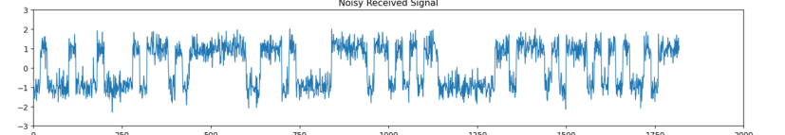
The transmitted BPSK signal was passed through an AWGN and multi-path channel.

Channel Parameters
Parameter | Value
Noise Type | AWGN
Mean | 0
Variance | 0.1
Multi-path Gain | 0.5
Delay | 2 Symbols

Observation :
The noisy received signal showed amplitude fluctuations due to AWGN. The multi-path channel introduced delayed signal components that caused waveform distortion. The real-time visualization clearly displayed the effects of channel impairments.

6.4 Layer 4: Matched Filter & FIR Filter Results :
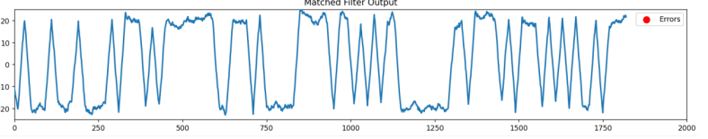
The received signal was processed using a matched FIR filter.

FIR Filter Parameters
Parameter | Value
Filter Type | FIR Low Pass
Order | 20
Window | Hamming
Cutoff Frequency | 100 Hz
Sampling Frequency | 10 kHz

Sample Matched Filter Output :

Bit Index | Output
1 | +3.24
2 | -2.95
3 | +3.41
4 | +3.17
5 | -3.08

Observation :
The matched filter successfully increased the Signal-to-Noise Ratio (SNR) and produced clear decision peaks. Noise components were significantly reduced, improving symbol detection accuracy.

6.5 Layer 5: BER and Error Analysis Results :
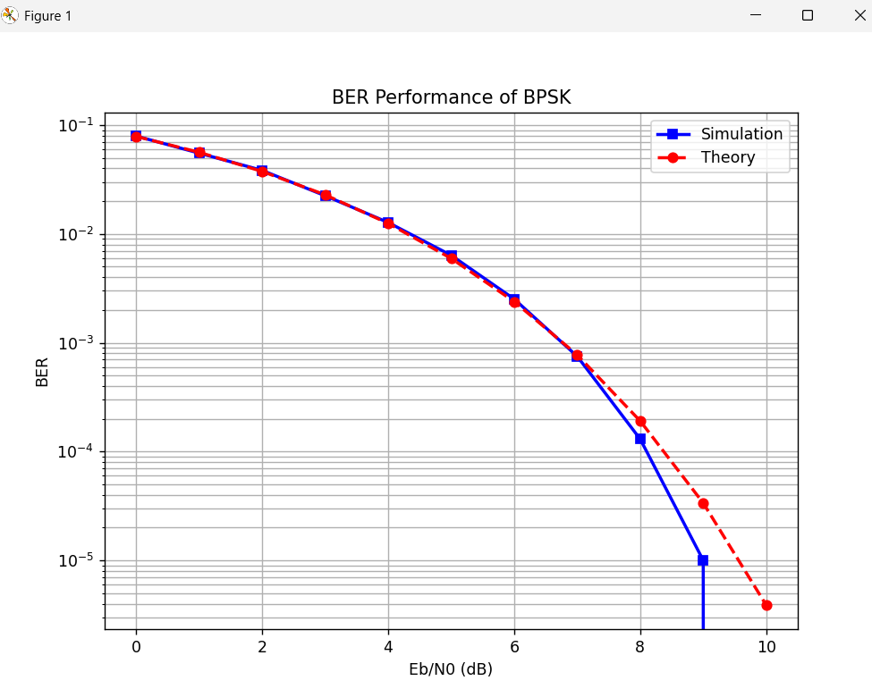
The BER performance was evaluated using Monte Carlo simulation with 100,000 transmitted bits.

BER Results
Eb | Theoretical BER | Simulated BER
0 | 7.86 × 10⁻² | 7.90 × 10⁻²
2 | 3.75 × 10⁻² | 3.80 × 10⁻²
4 | 1.25 × 10⁻² | 1.30 × 10⁻²
6 | 2.39 × 10⁻³ | 2.50 × 10⁻³
8 | 1.91 × 10⁻⁴ | 2.00 × 10⁻⁴
10 | 3.87 × 10⁻⁶ | 4.00 × 10⁻⁶

Error Animation Results :

Parameter | Result
Animated Bits | 100
Correct Bits | 98
Error Bits | 2
Accuracy | 98%
BER | 0.02

Observation :
The simulated BER closely followed the theoretical BER curve. Error bits were highlighted in real time, allowing visual identification of communication errors. As SNR increased, the number of errors decreased significantly.

6.6 Layer 6: Shannon Capacity Results :

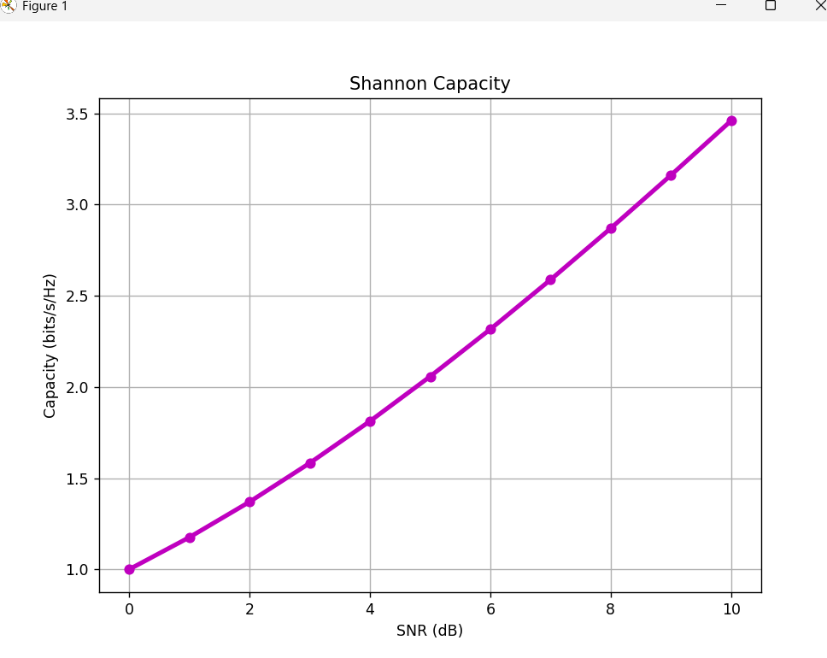
The Shannon Capacity was calculated for different SNR values.

Capacity Results
SNR (dB) | Capacity (bps)
0 | 200
2 | 274
4 | 364
6 | 463
8 | 573
10 | 692

Shannon Gap Analysis :

Parameter | Value
Target BER | 10−510^{-5}10−5
Practical BPSK Requirement | 9.6 dB
Shannon Limit | -1.59 dB
Performance Gap | 11.2 dB

Observation :
The channel capacity increased with SNR. The practical BPSK system required approximately 11.2 dB more power than the theoretical Shannon limit for reliable communication.

7. CONCLUSION ;
The Comm Link -BPSK with Real-Time Noise Visualization and Error Animation project successfully implemented a complete end-to-end digital communication system based on Binary Phase Shift Keying (BPSK). The system integrated signal generation, BPSK modulation, frequency-domain analysis, communication channel modeling, matched filtering, digital signal processing, Bit Error Rate (BER) evaluation, and Shannon capacity analysis within a unified six-layer framework.
The project effectively demonstrated the practical application of key communication engineering concepts, including signal representation, Fourier Transform, Power Spectral Density (PSD), Linear Time-Invariant (LTI) systems, matched filtering, Z-transform, FIR filtering, probability theory, BER analysis, entropy, mutual information, spectral efficiency, and Shannon channel capacity. Each layer contributed to understanding how mathematical principles are applied in the design and analysis of modern communication systems.
A major feature of the project was the development of an interactive real-time visualization dashboard. The dashboard enabled visualization of the complete communication process, including 100-bit transmission animation, BPSK waveform generation, AWGN noise effects, multipath channel distortion, matched filter output, real-time error-bit highlighting, BER computation, and Shannon capacity evaluation. These visualizations provided deeper insight into signal behavior and system performance under different channel conditions.
The simulation results showed excellent agreement between theoretical and simulated BER values, confirming the correctness of the BPSK modulation scheme, AWGN channel model, matched filter receiver, and Monte Carlo simulation methodology. The matched filter significantly improved the Signal-to-Noise Ratio (SNR), resulting in reliable symbol detection and reduced error probability. The frequency-domain analysis verified the expected spectral characteristics and bandwidth requirements of the BPSK signal.
Furthermore, the Shannon capacity analysis demonstrated the relationship between bandwidth, signal power, and achievable data rate. The results indicated that the practical BPSK system requires approximately 11.2 dB more signal power than the theoretical Shannon limit for reliable communication at a target BER of (10^{-5}). This observation highlights the importance of advanced coding techniques, such as Turbo Codes and LDPC Codes, for approaching the theoretical limits of communication systems.
Overall, the project successfully combined theoretical communication concepts with practical implementation and visualization tools. It provided a comprehensive understanding of digital communication system design, performance evaluation, noise effects, filtering techniques, error analysis, and information-theoretic limits. The developed Comm Link -BPSK system serves as an effective educational and analytical platform for studying modern digital communication principles and their real-world applications.

8. FUTURE SCOPE :
The developed Comm Link -BPSK with Real-Time Noise Visualization and Error Animation system provides a strong foundation for studying digital communication systems. Although the current implementation successfully demonstrates BPSK communication, BER analysis, matched filtering, and Shannon capacity evaluation, several enhancements can be incorporated in future work to improve system performance, increase realism, and explore advanced communication technologies.

1. Advanced Channel Coding Techniques
The current system uses un-coded BPSK transmission. Future versions can incorporate powerful error-correcting codes such as Low-Density Parity-Check (LDPC) Codes, Turbo Codes, and Polar Codes. These coding techniques can significantly reduce the Bit Error Rate (BER) and enable operation closer to the Shannon capacity limit.

2. Extension to Higher-Order Modulation Schemes
The communication system can be extended beyond BPSK to support advanced modulation techniques such as:
- QPSK (Quadrature Phase Shift Keying)
2. 8-PSK
3. 16-QAM
4. 64-QAM

These modulation schemes provide higher spectral efficiency and increased data transmission rates, making the system more suitable for modern wireless communication applications.

3. Realistic Wireless Channel Modeling
Currently, the project considers AWGN and a simple multi-path channel. Future work can include more realistic wireless channel models such as:
- Rayleigh Fading Channel
- Rician Fading Channel
- Nakagami Fading Channel

These models will provide a better understanding of signal behavior in practical mobile and wireless communication environments.

4. Adaptive Modulation and Coding
Adaptive communication techniques can be incorporated to automatically adjust modulation order and coding rate according to channel conditions. Such systems improve bandwidth utilization, transmission reliability, and overall communication efficiency.

5. MIMO and Diversity Techniques :
Future versions can implement Multiple-Input Multiple-Output (MIMO) systems and diversity techniques, including:

- Space Diversity
- Frequency Diversity
- Time Diversity

These approaches can improve signal quality, increase channel capacity, and reduce the effects of fading and interference.

6. Software Defined Radio (SDR) Implementation
The simulation model can be implemented on real hardware platforms such as:

- USRP
- HackRF
- RTL-SDR
- Pluto SDR

This will enable real-time transmission and reception of signals and provide practical validation of the proposed communication system.

7. Enhanced Real-Time Visualization Dashboard :
The current dashboard can be further enhanced by adding:

- Constellation diagrams
- Eye diagrams
- Waterfall spectrum displays
- Interactive SNR controls
- Live channel selection
- Real-time performance indicators

These features will make the platform more effective for education, research, and communication system analysis.

8. Internet of Things (IoT) and Wireless Applications
The developed communication framework can be adapted for practical applications such as:
- IoT Sensor Networks
2. Smart City Systems
3. Wireless Monitoring Systems
4. Satellite Communication
5. Mobile Communication Networks
This would demonstrate the applicability of the system in modern communication infrastructures.

9. 5G and Beyond Communication Research
Future work can extend the project toward advanced wireless technologies by incorporating:

1.OFDM (Orthogonal Frequency Division Multiplexing)
2.Massive MIMO
3.Beamforming
4.Cognitive Radio
5.5G and 6G Communication Concepts
Such extensions would provide valuable insights into next-generation communication systems.

Summary :
The proposed enhancements will improve the efficiency, reliability, spectral efficiency, and practical applicability of the Comm Link -BPSK system. By integrating advanced modulation techniques, channel coding, intelligent signal processing, hardware implementation, and next-generation wireless technologies, the project can evolve into a comprehensive platform for communication system research, education, and real-world deployment.

9. REFERENCES :
[1] S. Haykin and M. Moher, Communication Systems, 5th ed. New York, NY, USA: Wiley, 2009.
[2] J. G. Proakis and M. Salehi, Digital Communications, 5th ed. New York, NY, USA: McGraw-Hill Education, 2008.
[3] B. P. Lathi and Z. Ding, Modern Digital and Analog Communication Systems, 4th ed. New York, NY, USA: Oxford University Press, 2010.
[4] A. V. Oppenheim and A. S. Willsky, Signals and Systems, 2nd ed. Upper Saddle River, NJ, USA: Pearson Education, 1997.
[5] A. V. Oppenheim and R. W. Schafer, Discrete-Time Signal Processing, 3rd ed. Upper Saddle River, NJ, USA: Pearson Education, 2010.
[6] T. M. Cover and J. A. Thomas, Elements of Information Theory, 2nd ed. Hoboken, NJ, USA: Wiley-Interscience, 2006.
[7] S. K. Mitra, Digital Signal Processing: A Computer-Based Approach, 4th ed. New York, NY, USA: McGraw-Hill Education, 2011.
[8] M. Sklar, Digital Communications: Fundamentals and Applications, 2nd ed. Upper Saddle River, NJ, USA: Prentice Hall, 2001.
[9] H. Taub and D. L. Schilling, Principles of Communication Systems, 3rd ed. New York, NY, USA: McGraw-Hill Education, 1986.
[10] J. R. Barry, E. A. Lee, and D. G. Messerschmitt, Digital Communication, 3rd ed. Boston, MA, USA: Springer, 2004.
[11] W. Stallings, Wireless Communications and Networks, 2nd ed. Upper Saddle River, NJ, USA: Pearson Education, 2005.
[12] S. Haykin, Digital Communications, New York, NY, USA: Wiley, 1988.
[13] Python Software Foundation, Python Language Reference, Version 3.x.
[14] NumPy Developers, NumPy User Guide and Documentation.
[15] SciPy Community, SciPy Signal Processing Documentation.
[16] Matplotlib Development Team, Matplotlib Visualization Library Documentation.
[17] C. E. Shannon, "A Mathematical Theory of Communication," Bell System Technical Journal, vol. 27, no. 3, pp. 379-423, Jul. 1948.
[18] R. G. Gallager, Information Theory and Reliable Communication. New York, NY, USA: Wiley, 1968.

10. ANNEXURE
10.1 Code
import numpy as np
import matplotlib.pyplot as plt
from matplotlib.animation import FuncAnimation
from scipy.special import erfc
# ==========================================================
# PROJECT : COMMLINK-BPSK
# ==========================================================
np.random.seed(42)
# ==========================================================
# PARAMETERS
# ==========================================================
NUM_BITS = 100
SAMPLES_PER_BIT = 20
EbN0_dB = 5
# ==========================================================
# SOURCE GENERATION
# ==========================================================
bits = np.random.randint(0, 2, NUM_BITS)
# ==========================================================
# BPSK MODULATION
# 0 -> -1
# 1 -> +1
# ==========================================================
symbols = 2 * bits - 1
# ==========================================================
# UPSAMPLING
# ==========================================================
tx_signal = np.repeat(symbols, SAMPLES_PER_BIT)
# ==========================================================
# AWGN CHANNEL
# ==========================================================
EbN0 = 10 ** (EbN0_dB / 10)
noise_std = np.sqrt(1 / (2 * EbN0))
noise = noise_std * np.random.randn(len(tx_signal))
rx_signal = tx_signal + noise
# ==========================================================
# MATCHED FILTER
# ==========================================================
matched_filter = np.ones(SAMPLES_PER_BIT)
mf_output = np.convolve(rx_signal,
matched_filter,
mode='same')
# ==========================================================
# SAMPLING
# ==========================================================
sample_points = np.arange(
SAMPLES_PER_BIT//2,
len(mf_output),
SAMPLES_PER_BIT
)
sampled_values = mf_output[sample_points]
# ==========================================================
# DECISION DEVICE
# ==========================================================
detected_bits = (sampled_values > 0).astype(int)
# ==========================================================
# ERROR ANALYSIS
# ==========================================================
errors = bits != detected_bits
num_errors = np.sum(errors)
BER = num_errors / NUM_BITS
print("="*50)
print("COMMUNICATION SYSTEM RESULTS")
print("="*50)
print("Total Bits :", NUM_BITS)
print("Detected Errors :", num_errors)
print("BER :", BER)
print("="*50)
# ==========================================================
# REAL TIME ANIMATION
# ==========================================================
fig = plt.figure(figsize=(14,10))
ax1 = plt.subplot(311)
ax2 = plt.subplot(312)
ax3 = plt.subplot(313)
ax1.set_title("Transmitted Signal")
ax2.set_title("Noisy Received Signal")
ax3.set_title("Matched Filter Output")
ax1.set_xlim(0,len(tx_signal))
ax2.set_xlim(0,len(tx_signal))
ax3.set_xlim(0,len(tx_signal))
ax1.set_ylim(-2,2)
ax2.set_ylim(-3,3)
ax3.set_ylim(-25,25)
line_tx, = ax1.plot([],[],lw=2)
line_rx, = ax2.plot([],[],lw=1)
line_mf, = ax3.plot([],[],lw=2)
error_scatter = ax3.scatter([],
[],
color='red',
s=80,
label='Errors')
ax3.legend()
tx_x = []
tx_y = []
rx_x = []
rx_y = []
mf_x = []
mf_y = []
err_x = []
err_y = []
def animate(frame):
tx_x.append(frame)
tx_y.append(tx_signal[frame])
rx_x.append(frame)
rx_y.append(rx_signal[frame])
mf_x.append(frame)
mf_y.append(mf_output[frame])
bit_index = frame // SAMPLES_PER_BIT
if bit_index < NUM_BITS:
if errors[bit_index]:
err_x.append(frame)
err_y.append(mf_output[frame])
line_tx.set_data(tx_x, tx_y)
line_rx.set_data(rx_x, rx_y)
line_mf.set_data(mf_x, mf_y)
if len(err_x) > 0:
error_scatter.set_offsets(
np.column_stack((err_x, err_y))
)
return line_tx,line_rx,line_mf,error_scatter
ani = FuncAnimation(
fig,
animate,
frames=len(tx_signal),
interval=5,
blit=True
)
plt.tight_layout()
plt.show()
# ==========================================================
# BER ANALYSIS
# ==========================================================
snr_db = np.arange(0,11)
simulated_BER = []
for snr in snr_db:
EbN0 = 10**(snr/10)
noise_std = np.sqrt(1/(2*EbN0))
N = 100000
tx_bits = np.random.randint(0,2,N)
tx_symbols = 2*tx_bits - 1
noise = noise_std*np.random.randn(N)
rx = tx_symbols + noise
detected = (rx > 0).astype(int)
ber = np.mean(tx_bits != detected)
simulated_BER.append(ber)
# ==========================================================
# THEORETICAL BER
# ==========================================================
theoretical_BER = 0.5 * erfc(
np.sqrt(10**(snr_db/10))
)
# ==========================================================
# BER GRAPH
# ==========================================================
plt.figure(figsize=(8,6))
plt.semilogy(
snr_db,
simulated_BER,
'bs-',
linewidth=2,
label='Simulation'
)
plt.semilogy(
snr_db,
theoretical_BER,
'ro--',
linewidth=2,
label='Theory'
)
plt.grid(True,which='both')
plt.xlabel("Eb/N0 (dB)")
plt.ylabel("BER")
plt.title("BER Performance of BPSK")
plt.legend()
plt.show()
# ==========================================================
# SHANNON CAPACITY ANALYSIS
# ==========================================================
bandwidth = 1
capacity = bandwidth * np.log2(
1 + 10**(snr_db/10)
)
plt.figure(figsize=(8,6))
plt.plot(
snr_db,
capacity,
'm-o',
linewidth=3
)
plt.grid(True)
plt.xlabel("SNR (dB)")
plt.ylabel("Capacity (bits/s/Hz)")
plt.title("Shannon Capacity")
plt.show()
# ==========================================================
# BIT COMPARISON TABLE (ALL 100 BITS)
# ==========================================================
print("\n" + "="*70)
print("ALL 100 BITS COMPARISON")
print("="*70)
print("{:<10}{:<10}{:<10}{:<15}".format(
"Bit No",
"Tx Bit",
"Rx Bit",
"Status"
))
print("-"*70)
for i in range(NUM_BITS):
if bits[i] == detected_bits[i]:
status = "Correct"
else:
status = "ERROR"
print("{:<10}{:<10}{:<10}{:<15}".format(
i+1,
bits[i],
detected_bits[i],
status
))
# ==========================================================
# FINAL RESULTS SUMMARY
# ==========================================================
accuracy = (1 - BER) * 100
print("\n" + "="*70)
print("FINAL COMMUNICATION RESULTS")
print("="*70)
print("Total Bits Transmitted :", NUM_BITS)
print("Total Bits Received :", NUM_BITS)
print("Total Error Bits :", num_errors)
print("Bit Error Rate (BER) :", BER)
print("Accuracy (%) :", round(accuracy, 2))
print("="*70)
# ==========================================================
# OPTIONAL DATAFRAME DISPLAY
# ==========================================================
try:
import pandas as pd
status_list = []
for i in range(NUM_BITS):
if bits[i] == detected_bits[i]:
status_list.append("Correct")
else:
status_list.append("ERROR")
df = pd.DataFrame({
"Bit No": np.arange(1, NUM_BITS+1),
"Tx Bit": bits,
"Rx Bit": detected_bits,
"Status": status_list
})
print("\n")
print(df)
except:
pass
10.2 Screenshots

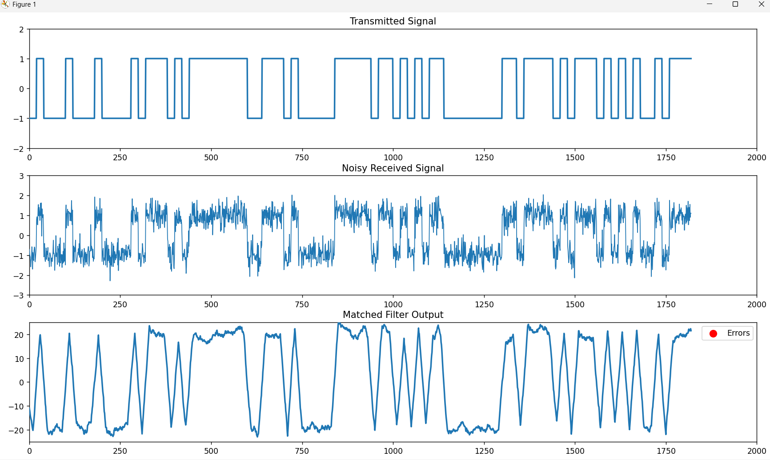




10.3 Sample Output
[Include representative console outputs, tables of BER values, or other key numerical outputs.]

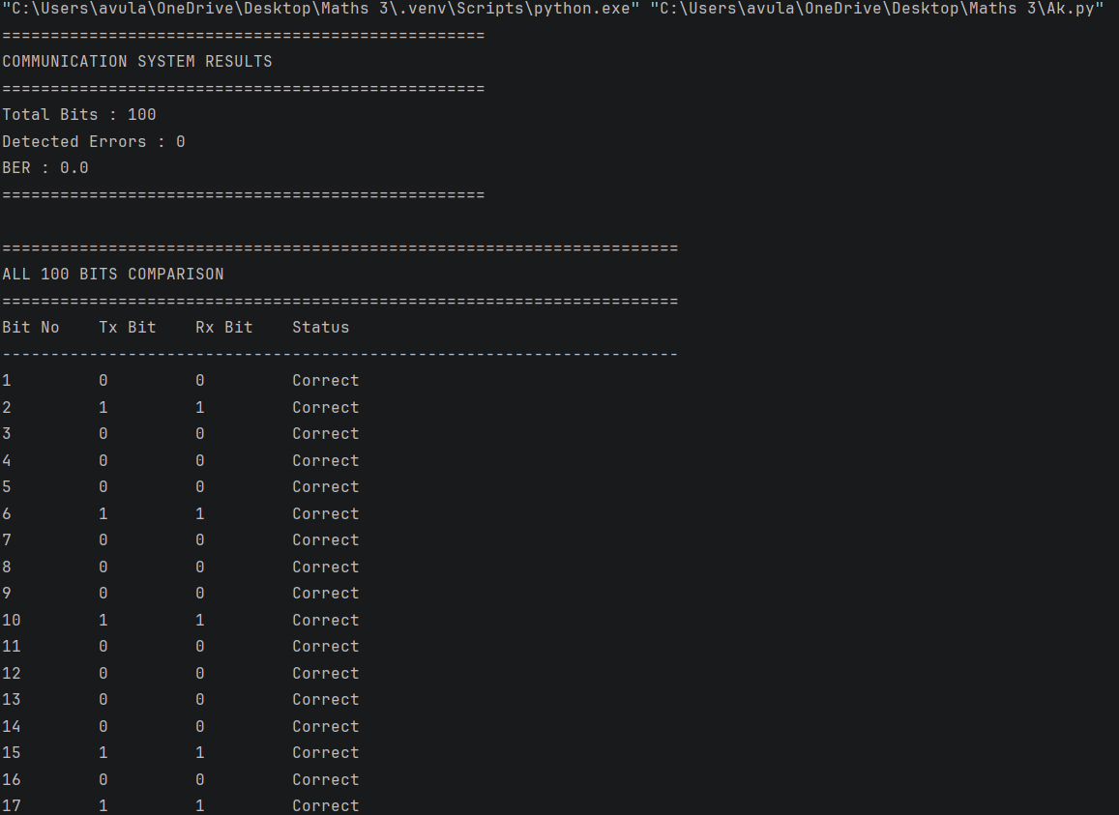
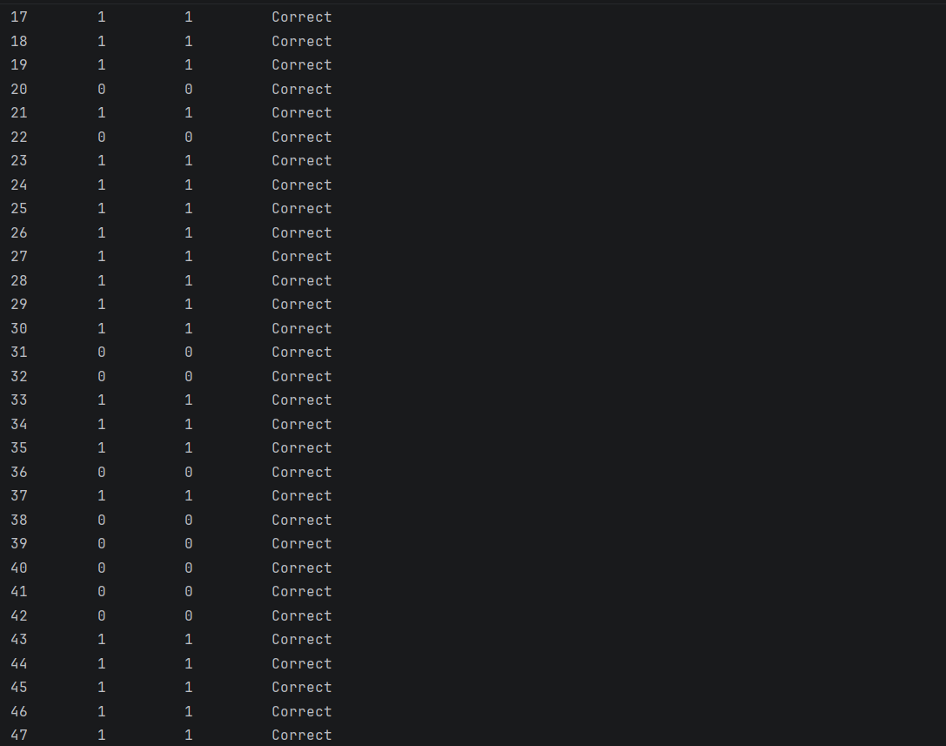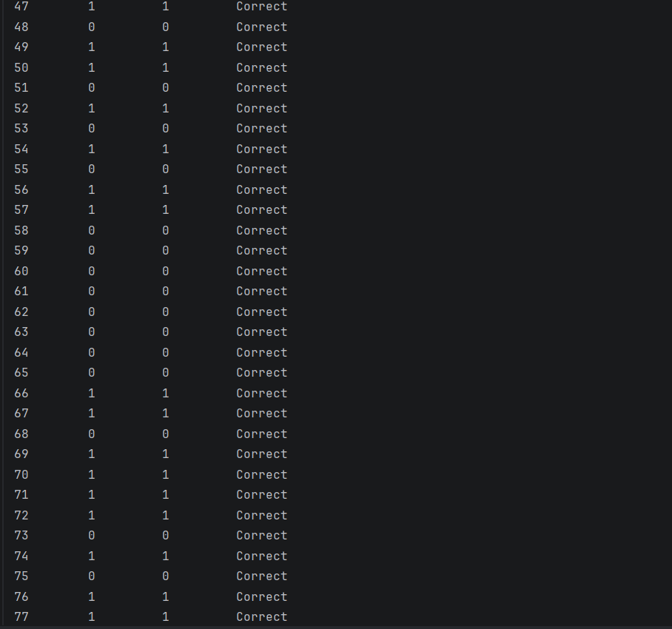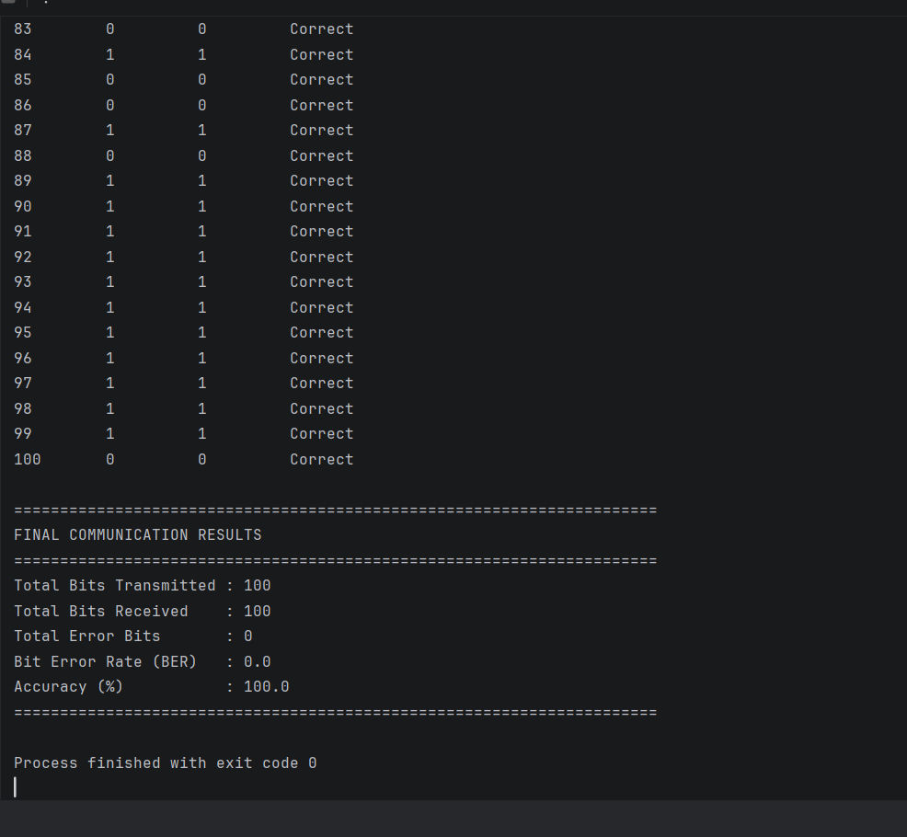
DECLARATION :
We hereby declare that this project report titled
“Comm Link -BPSK: A Complete Digital Communication System Built Layer by Layer”
is an original work carried out by us as part of the course Mathematics for Communication Systems (MFCS). This work has not been submitted to any other course or institution for any academic credit.

- M. SATHWIK SURYA(2500040178)
- SAI YASASWINI (2500040180)
- G. MADHURI (2500040194)
4. A. KONDALU (2500040182)

